**TASK FIVE**

**FILE HANDLING AND EXCEPTION HANDLING**

1. Write a program in Python to allow the error of syntax to be handled using exception handling.

HINT: Use SyntaxError

**Output-**

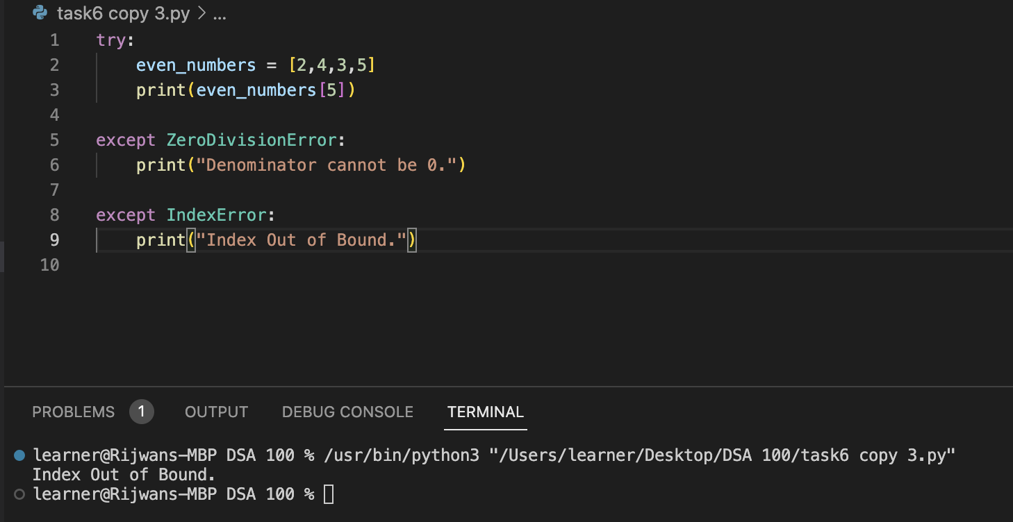

2. Write a program in Python to allow the user to open a file by using the argv module. If the

entered name is incorrect throw an exception and ask them to enter the name again. Make sure

to use read only mode

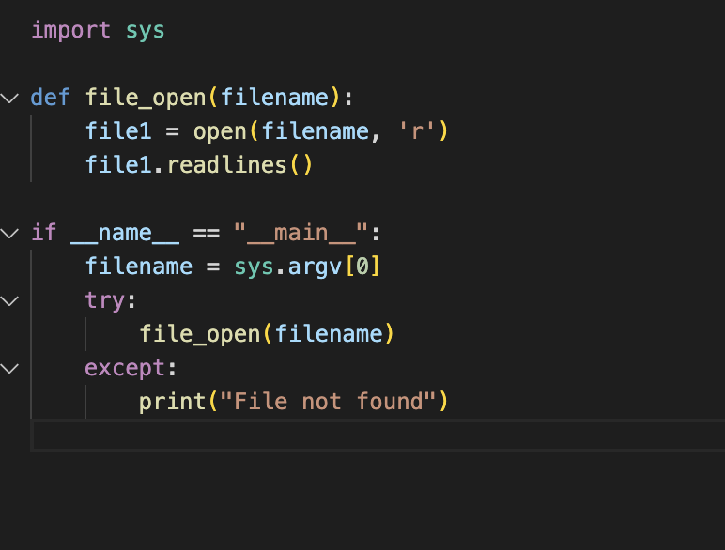

3. Write a program to handle an error if the user entered a number more than four digits it should

return “The length is too short/long !!! Please provide only four digits”

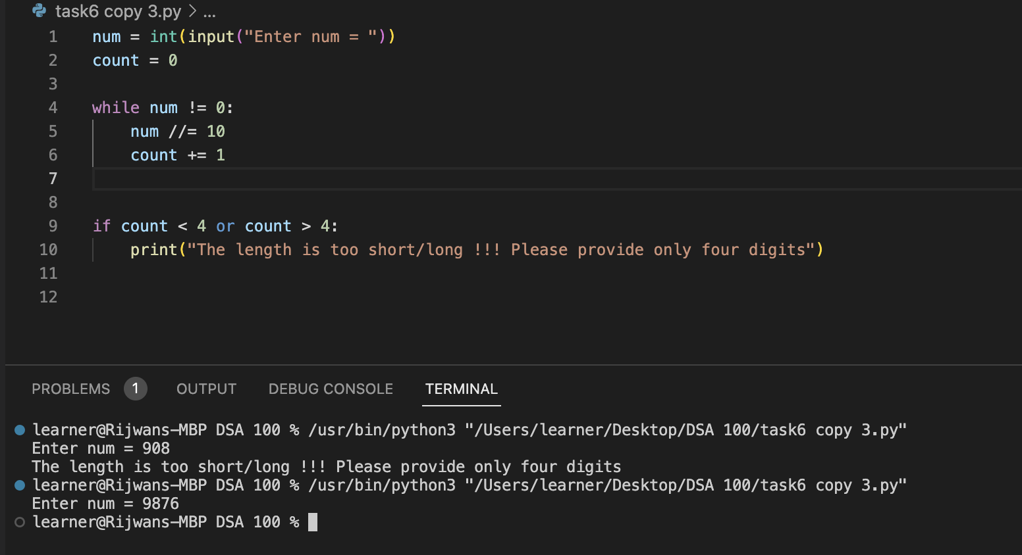

4. Create a login page backend to ask users to enter the username and password. Make sure to

ask for a Re-Type Password and if the password is incorrect give chance to enter it again but it

should not be more than 3 times.

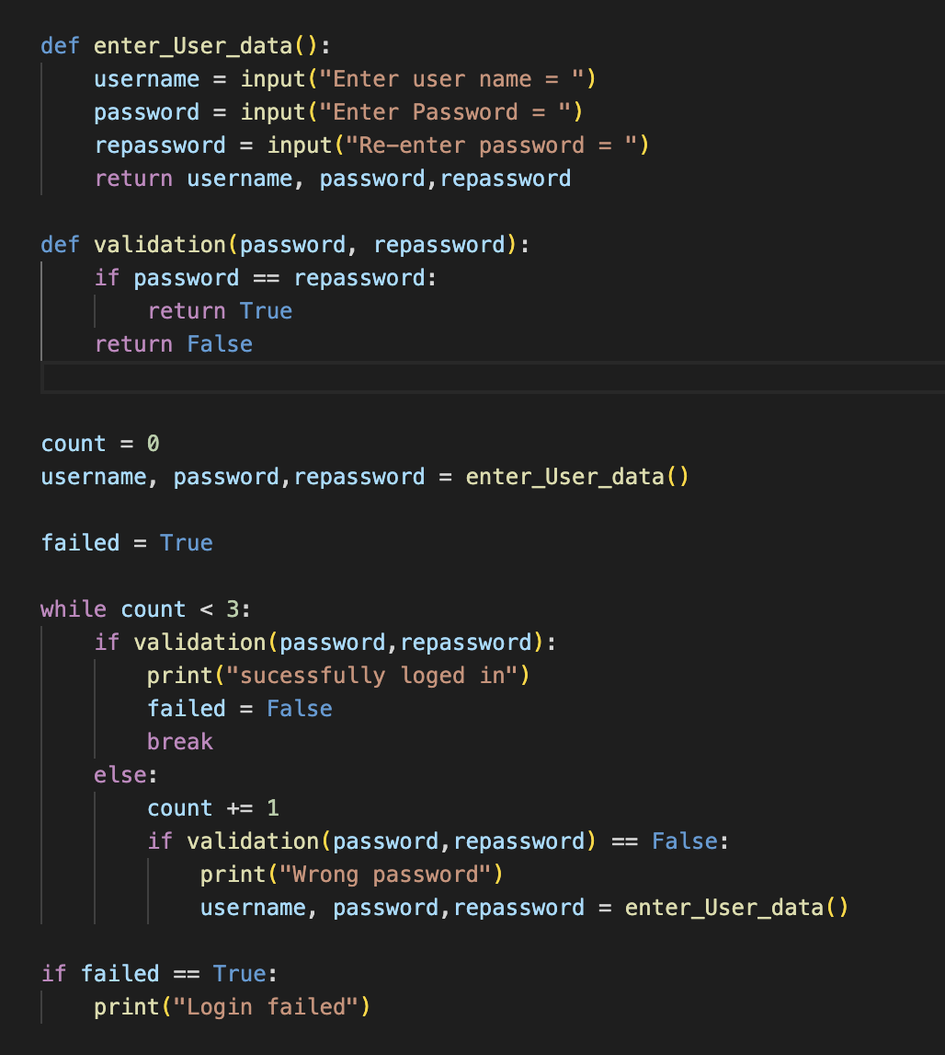

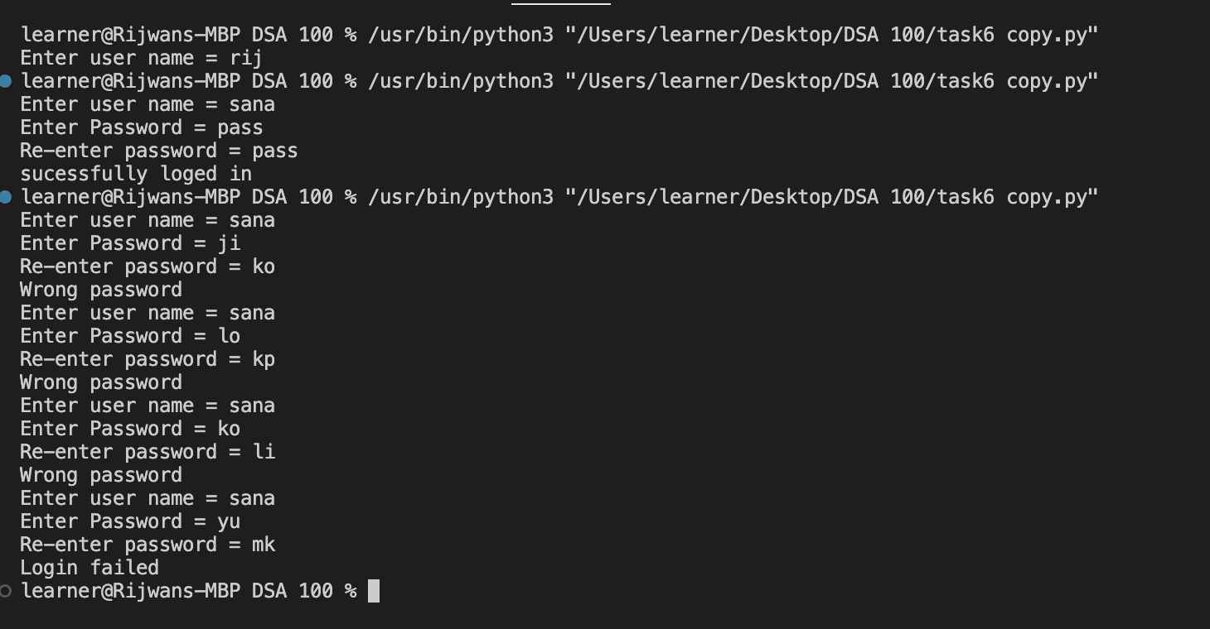

5. Go through the link provided below to understand finally and raise concept:

<https://www.programiz.com/python-programming/exception-handling>

6. Read doc.txt file using Python File handling concept and return only the even length string from

the file. Consider the content of doc.txt as given below:

Hello I am a file

Where you need to return the data string

Which is of even length

Make sure you return the content in The same link as it is present.

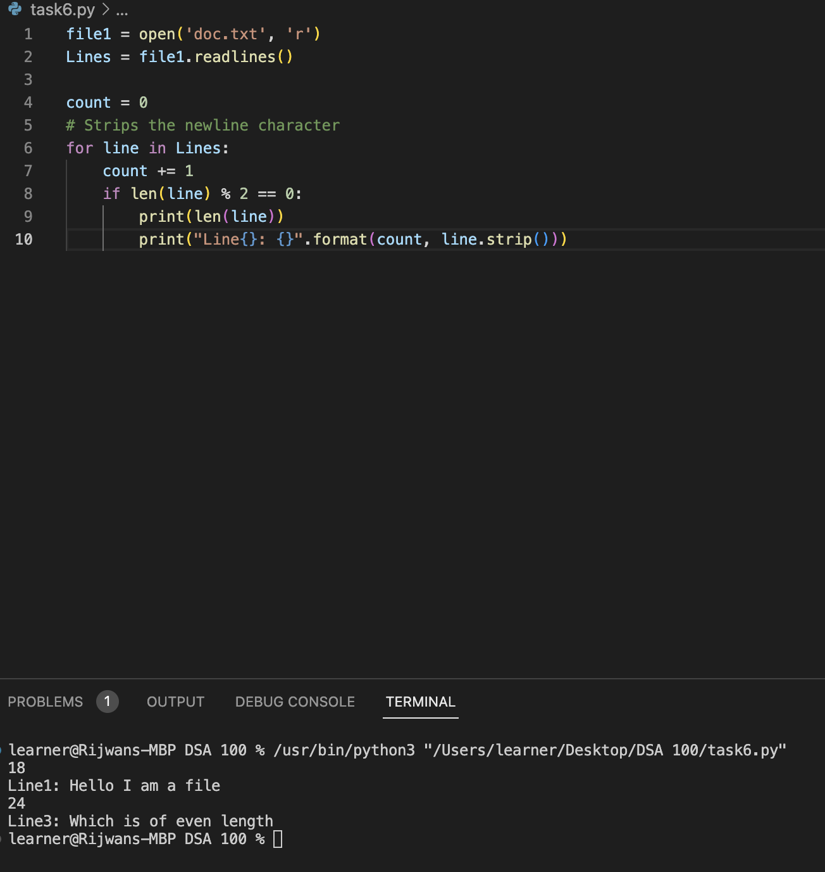

—---------------------------------

**TASK SIX**

**GENERATORS, LIST COMPREHENSION AND DECORATORS**

1. Write a program in Python to find out the character in a string which is uppercase using list

Comprehension.

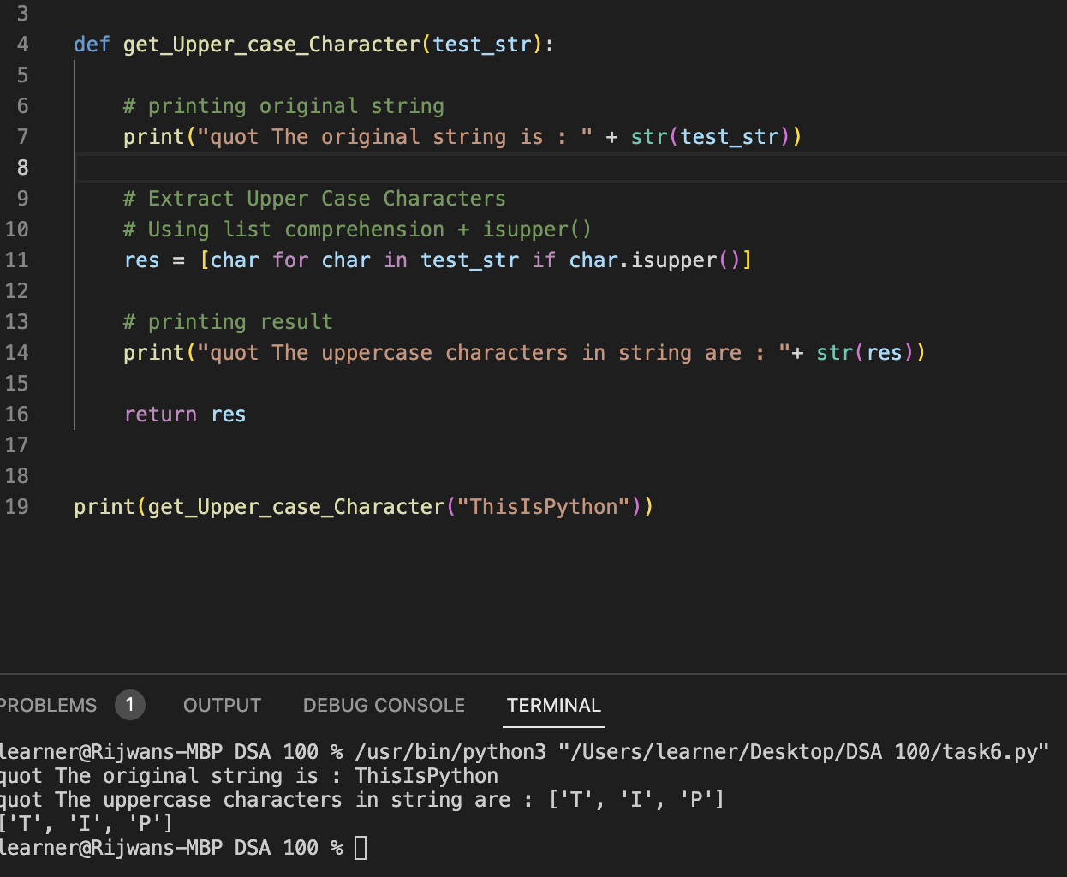

2. Write a program to construct a dictionary from the two lists containing the names of students and their corresponding subjects. The dictionary should map the students with their respective subjects.

Let’s see how to do this using for loops and dictionary comprehension.

HINT - Use Zip function also

Sample input: students = ['Smit', 'Jaya', 'Rayyan'] subjects = ['CSE', 'Networking', 'Operating System']

Expected output: {‘Smit’ : ’CSE’ , ’Jaya’ : ’Networking’ , ’Rayyan’ : ’Operating System’}

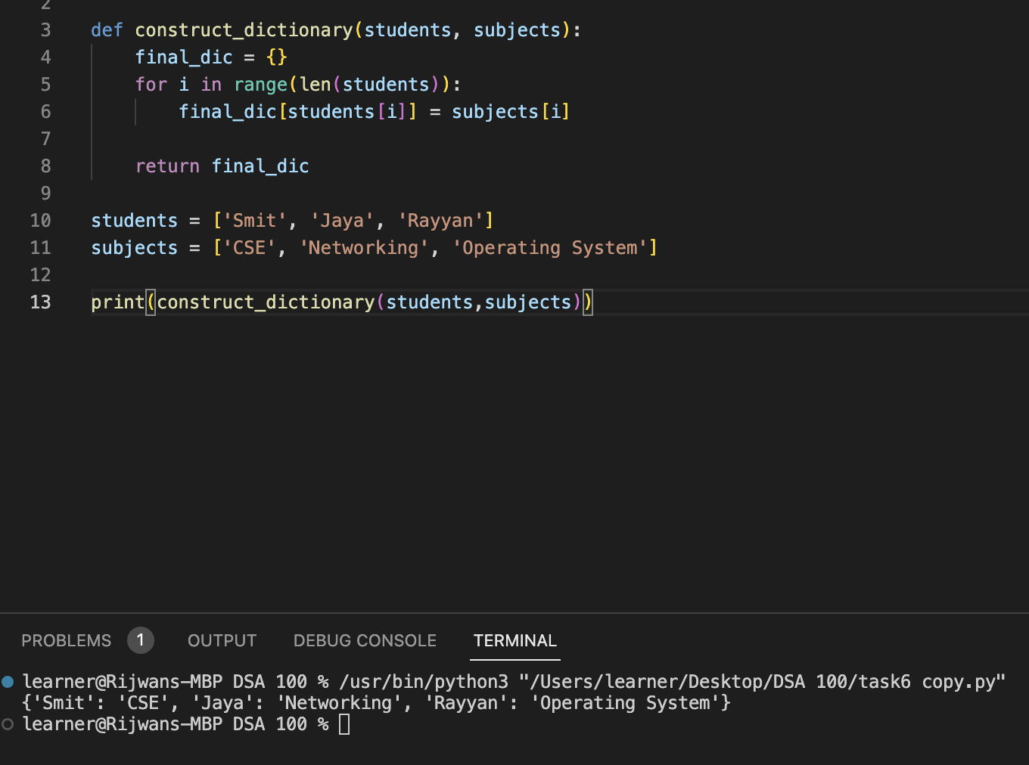

3. Learn More about Yield, next and Generators

4. Write a program in Python using generators to reverse the string.

Input String = “Consultadd Training”

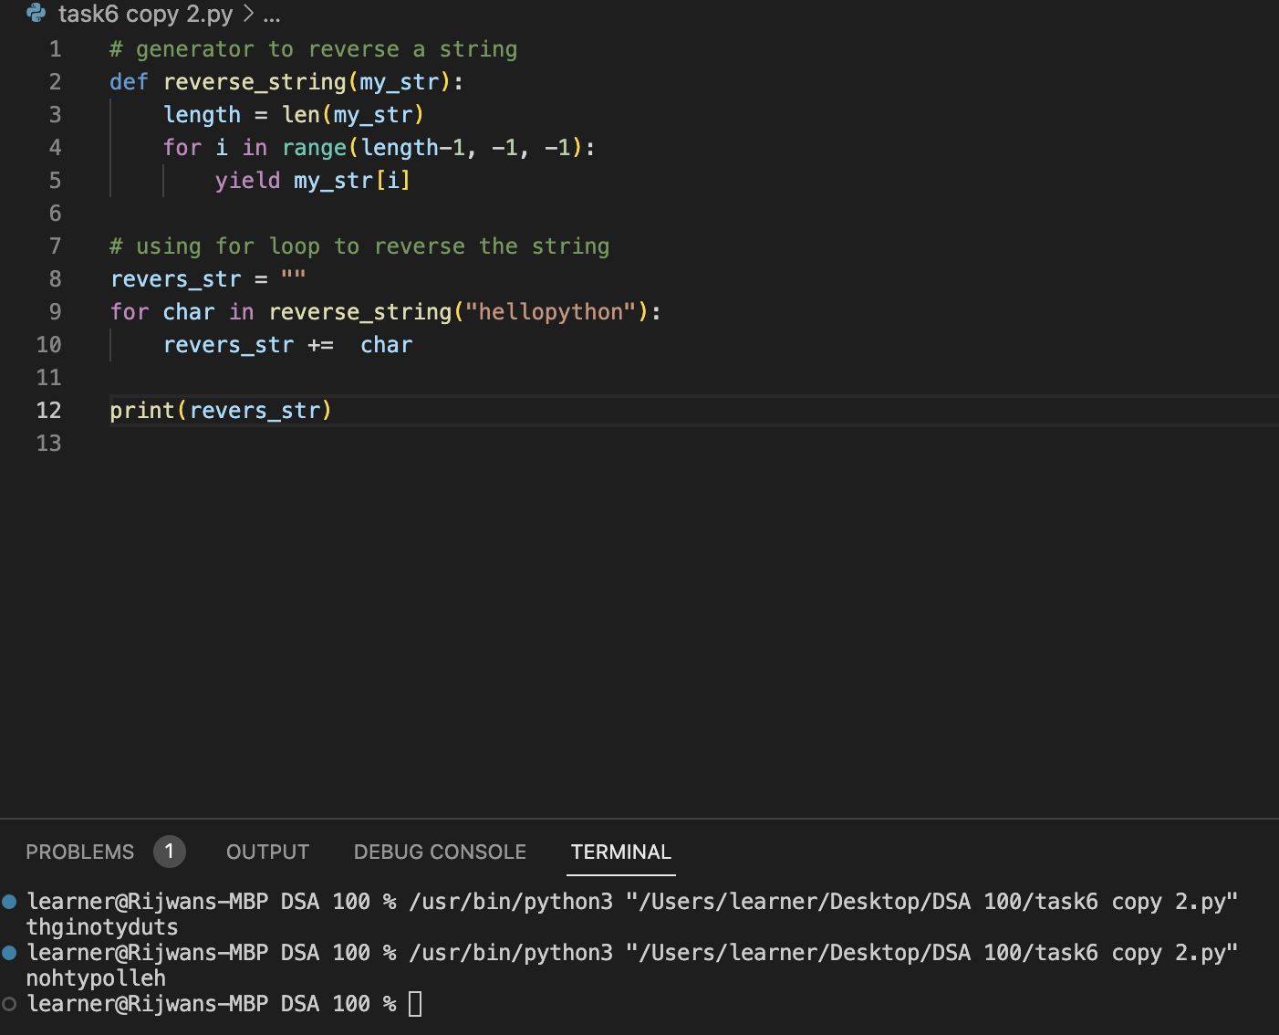

5. Write an example on decorators.

